Mato Chinja News
Issue 7
March 3rd, 2020
----------------------------------------------------------------------------------------------------------------------------

Basketball
The basketball games were slightly successful for the girls and not so much for the boys. Both the games on Friday and Saturday were pretty close for the girls (they took the phat dub!) but not so lucky for the boys.. On friday the girls score was: 45-57 against Nashua and the boys score was: 32-68. On Saturday the score against Lustre for the girls was: 47-44 and the boys score was: 29-74. Sadly, the boys did not win against Nashua or Lustre. So, districts were last week and the boys, sadly, did not take the dub. The girls took fat dubs and are now onto divisionals. They will be playing Thursday, February 27th at 5:00pm in Glasgow against Plentywood Wildcats. They only have to play two hard games and then their onto championship, but they also have to play Scobey if they win Plentywood. Good luck to the Lady Bearcubs at Divisionals, fans will all be there to support you girls.
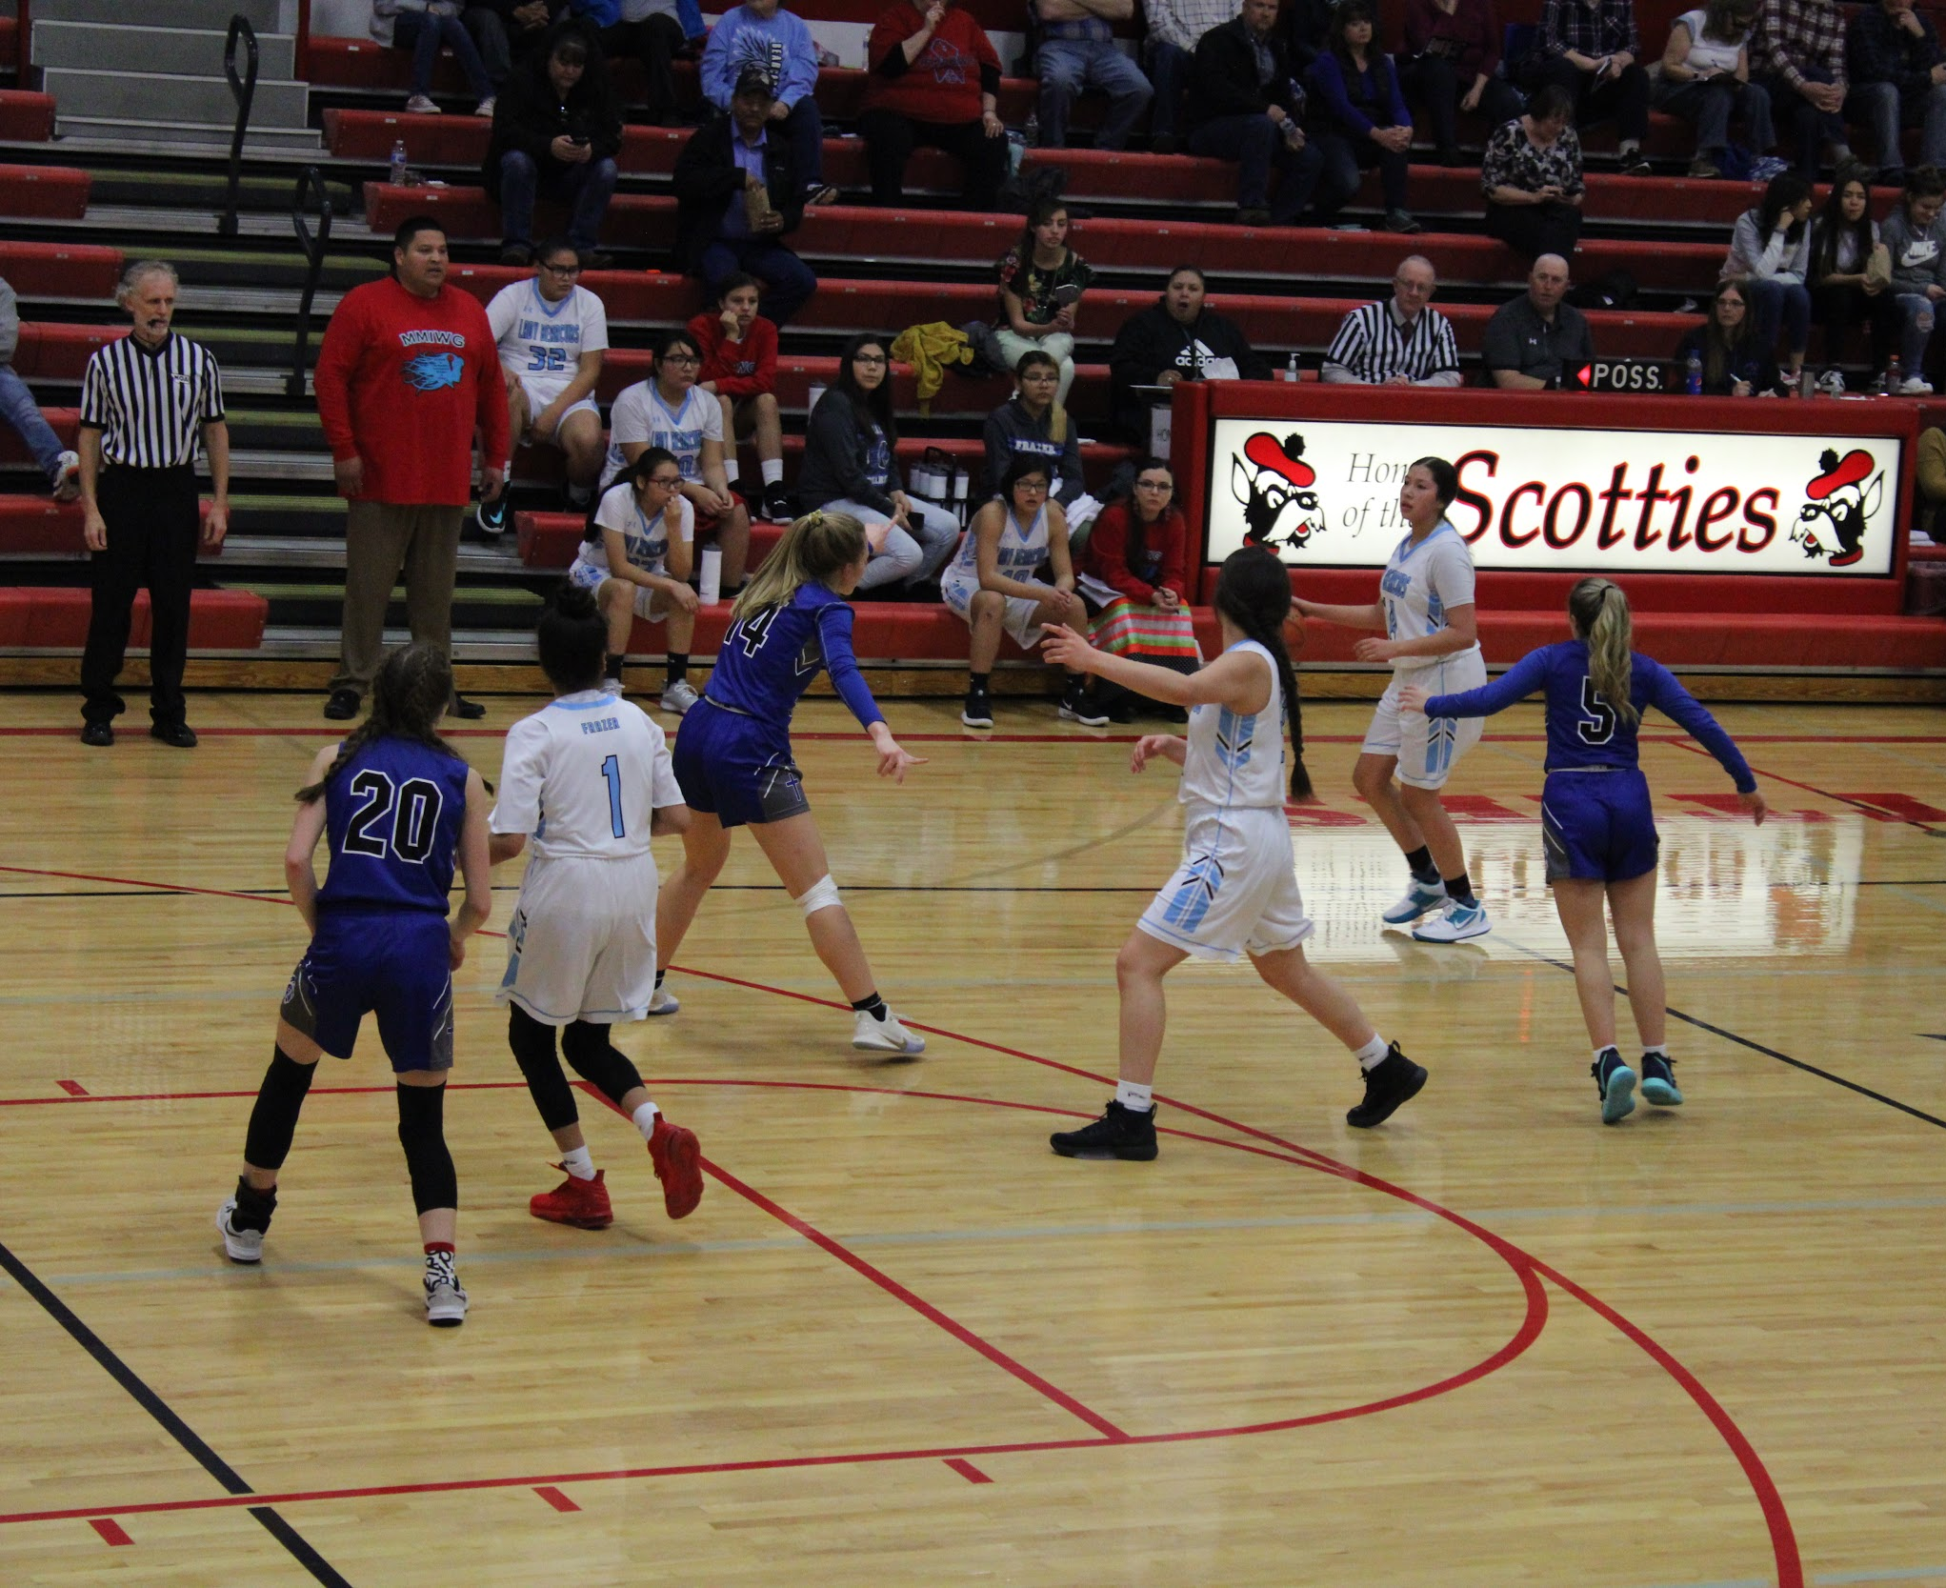
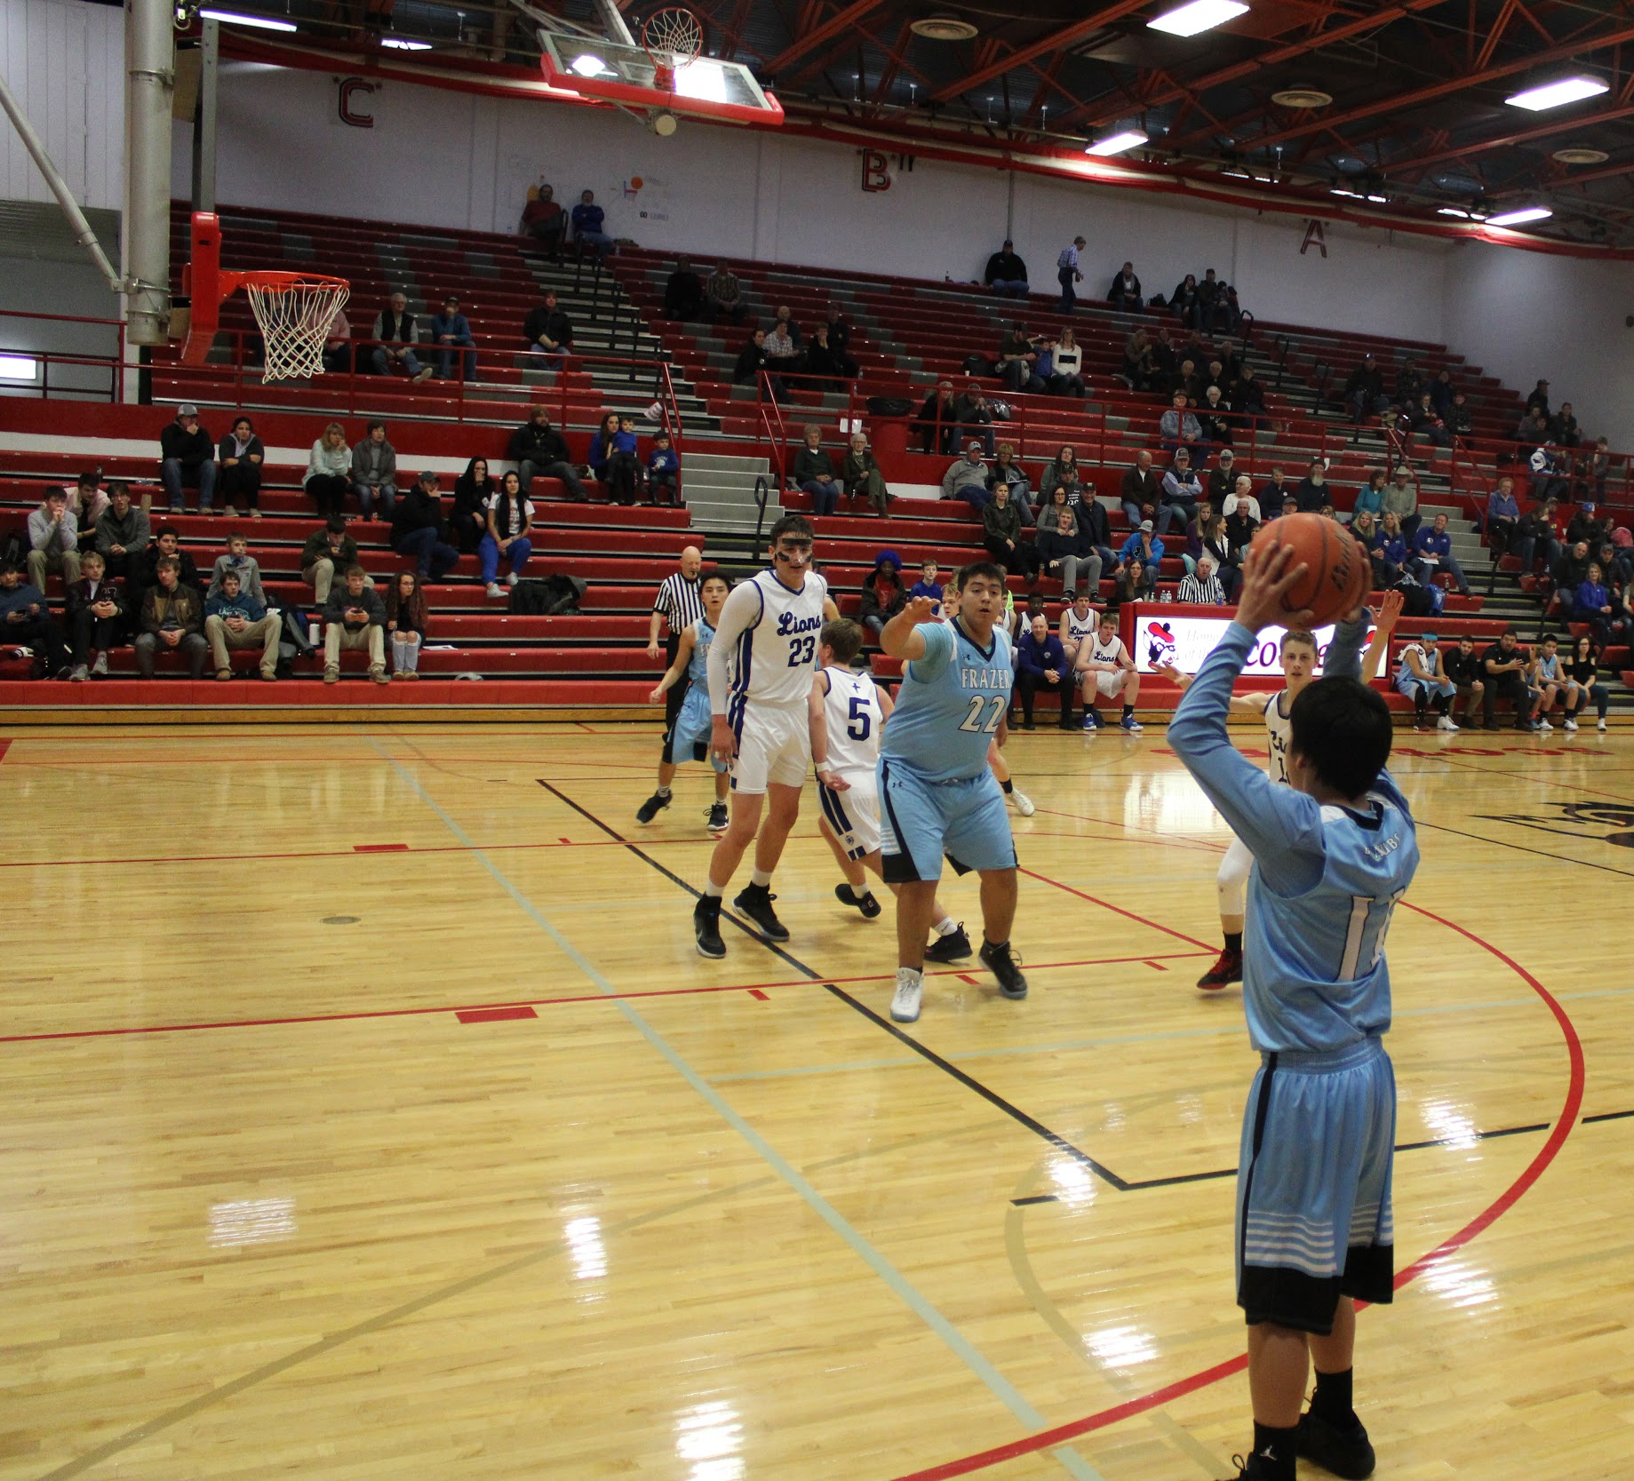

Spelling bee

Adeline Smoker
Dalles Blount
Noah Talksdifferent
Kaleanaesa Blount
Chris Fox
Madism Knowlter

These kids won the spelling bee at Frazer and then went to Nashua to compete in the regional spelling bee.
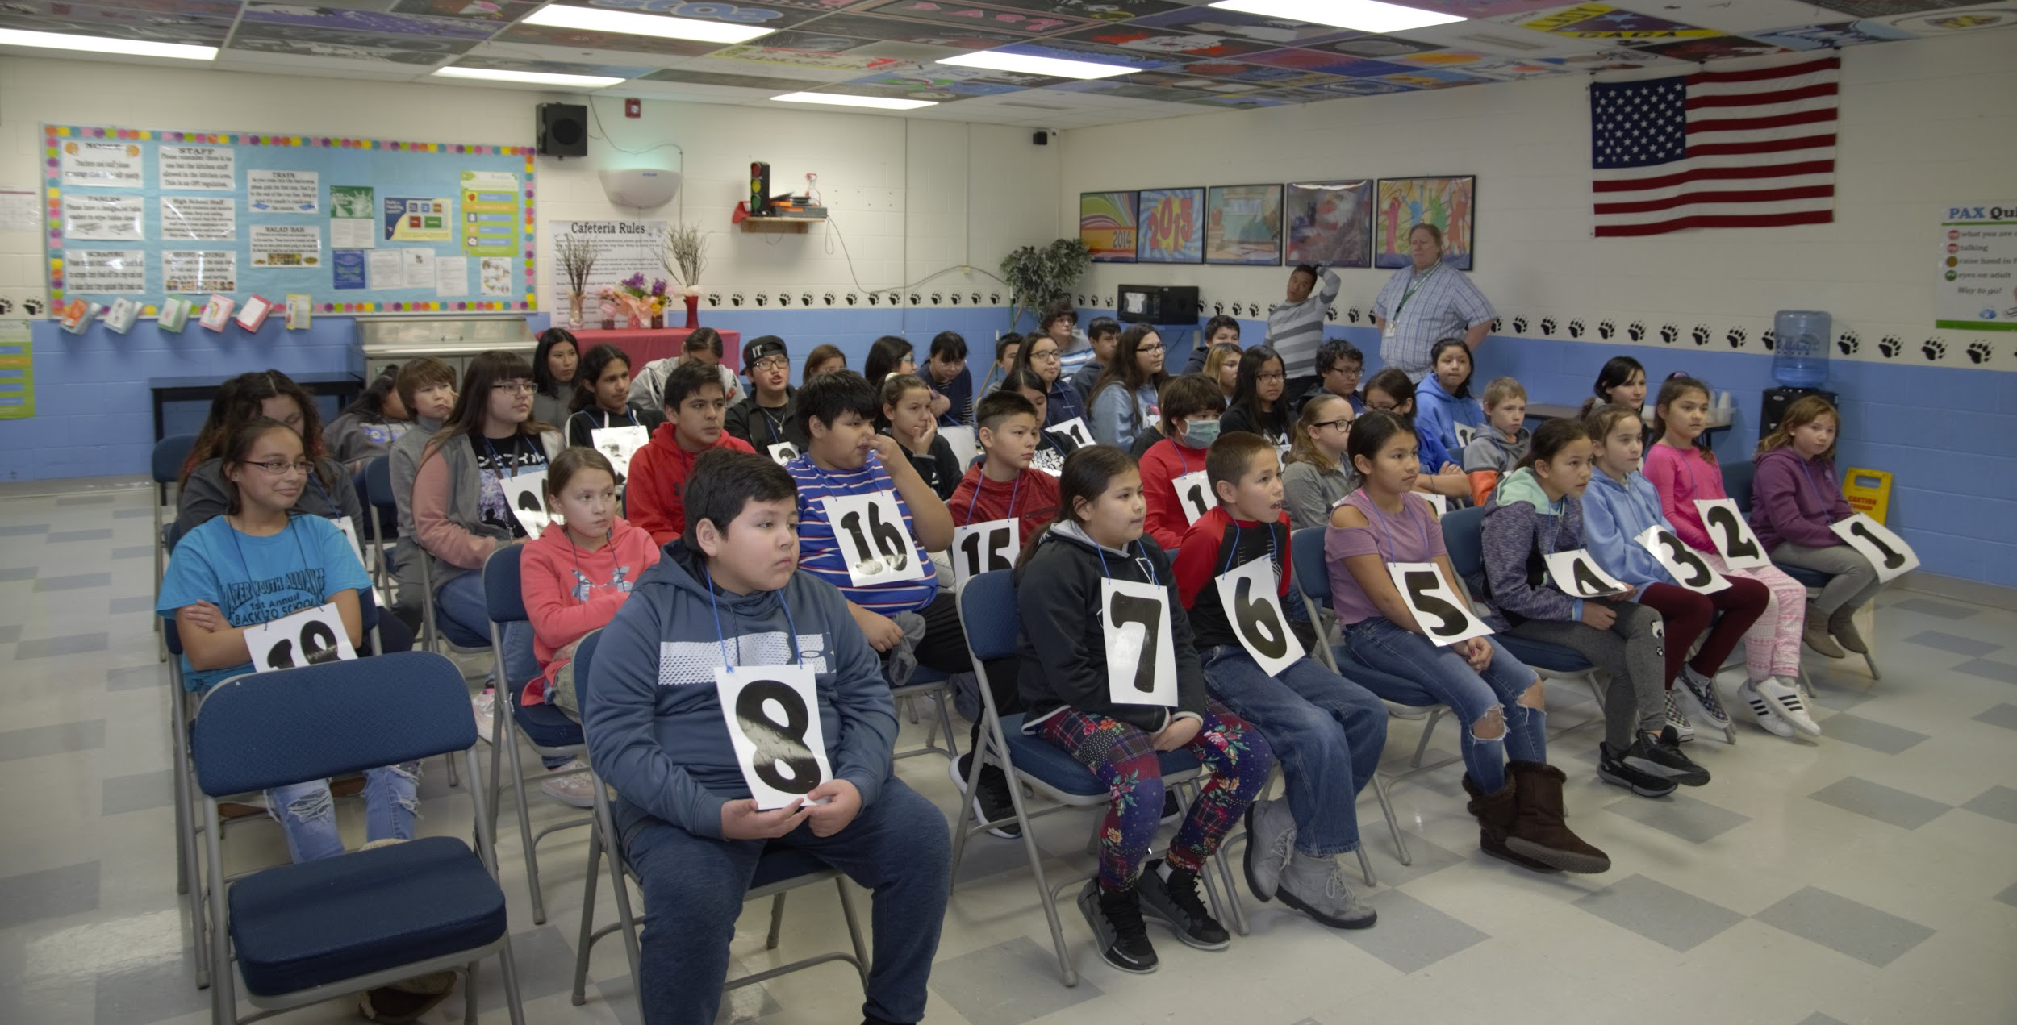

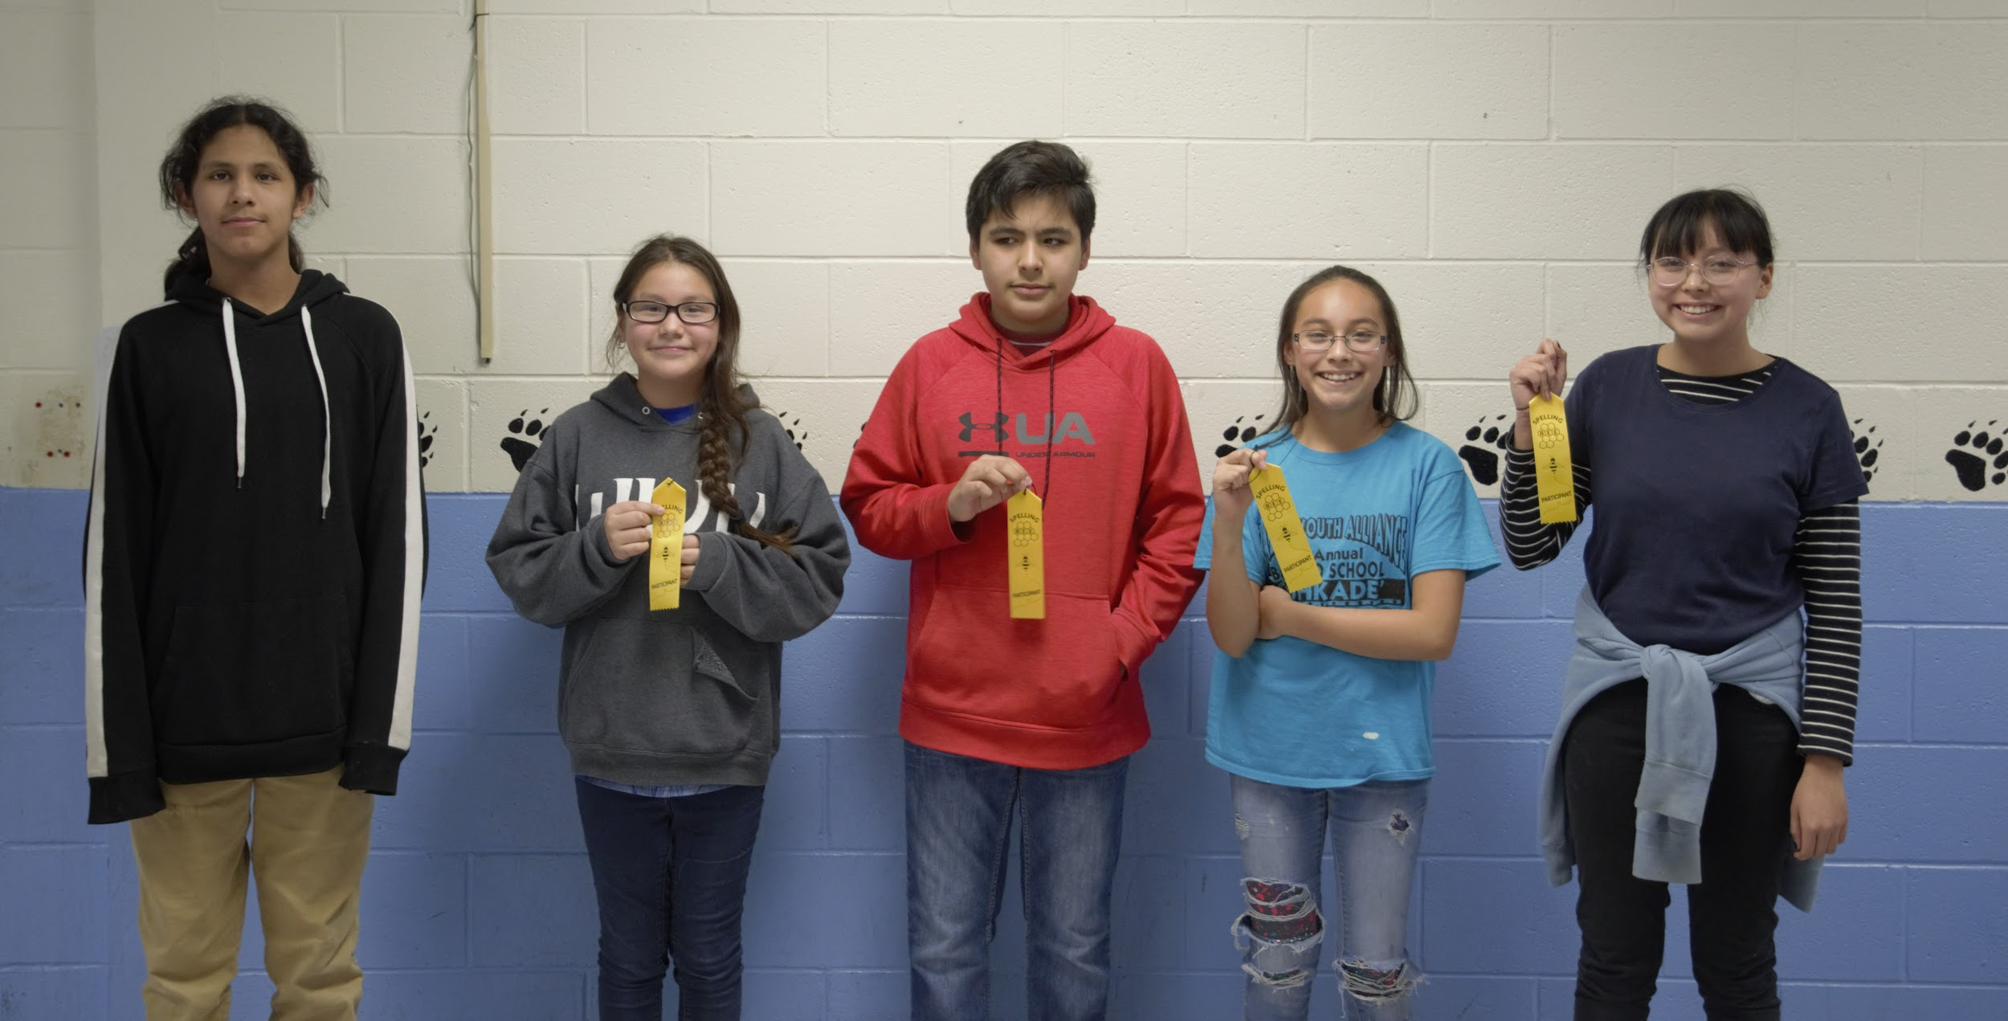

Sweethearts dance
The SweetHeart Dance was sponsored by the Student Council. The Dance was only for 7-12th grade, but You could bring an out of town guest if your out of town guest form was filled out. They had a great turn out, there was karaoke, and thank you everybody who went and participated at the dance.
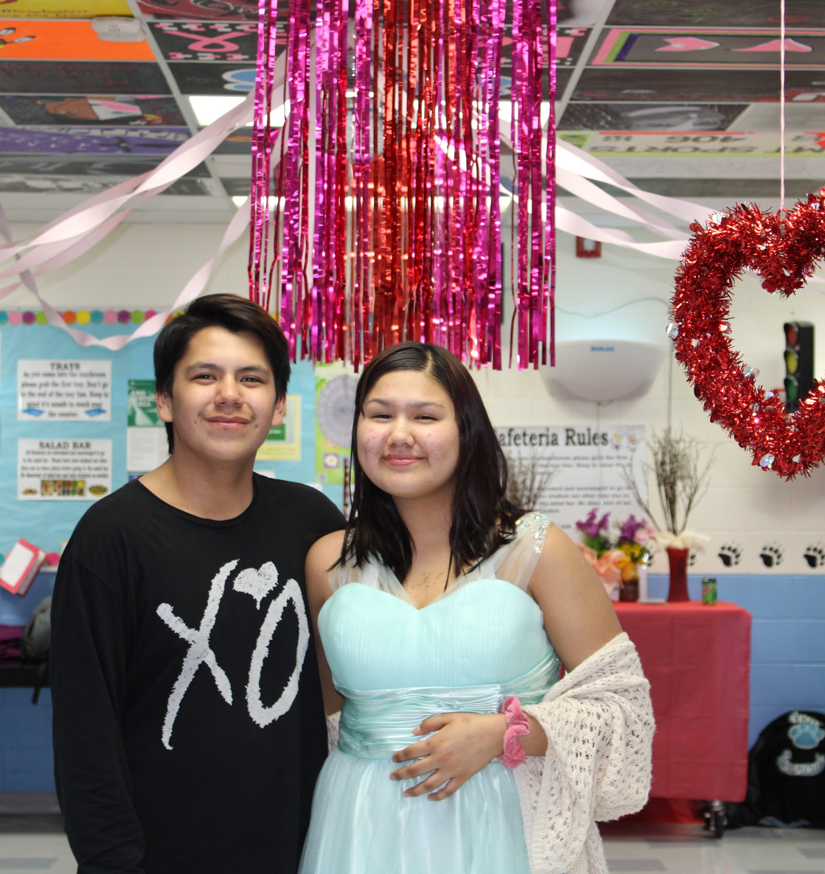



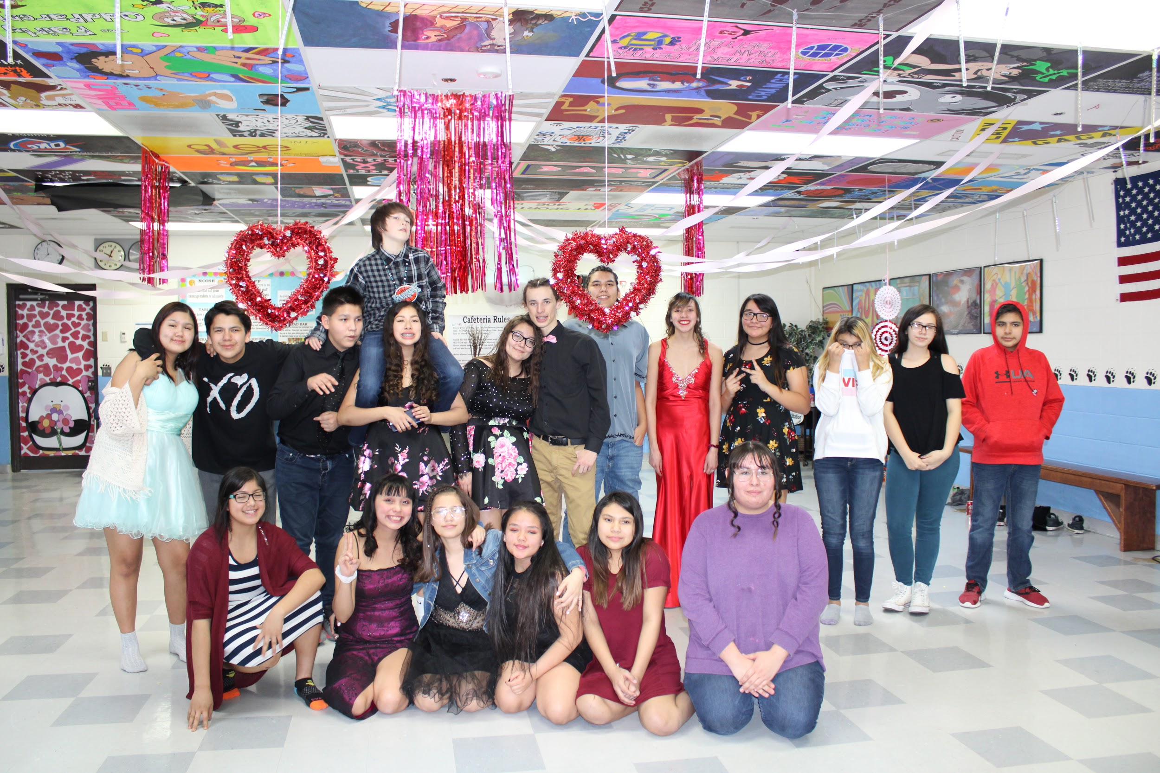

I love to read month
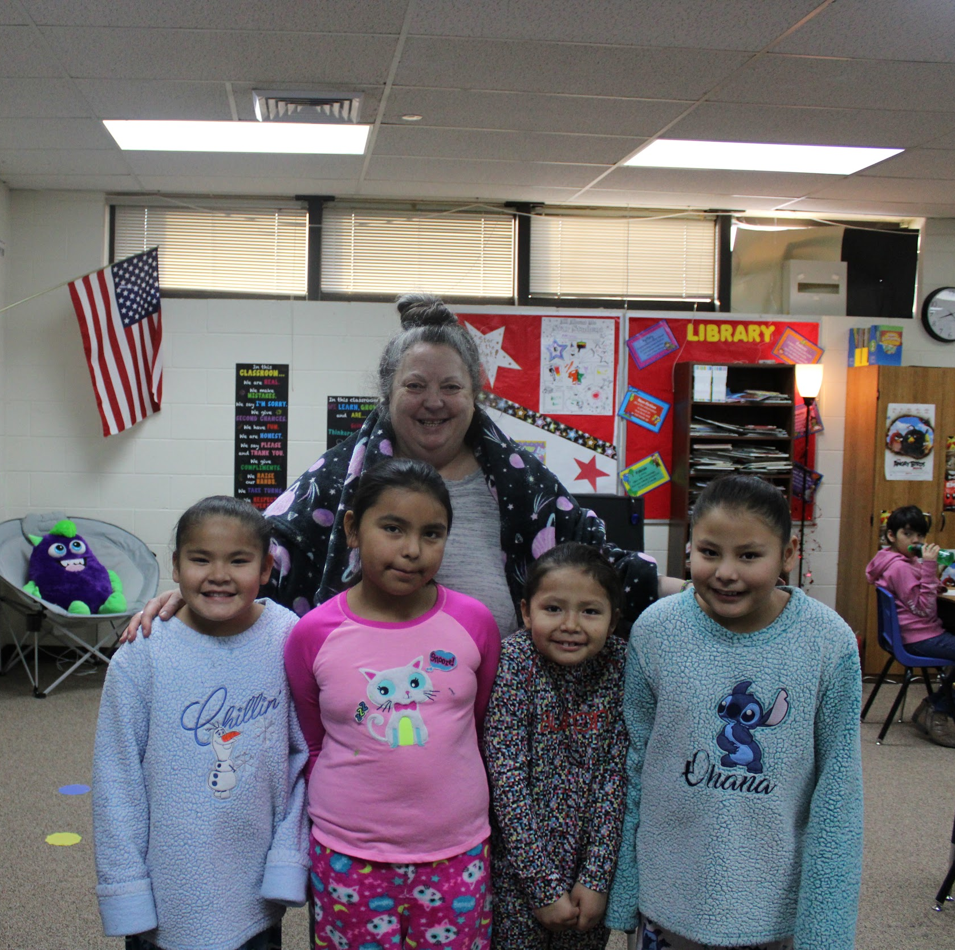
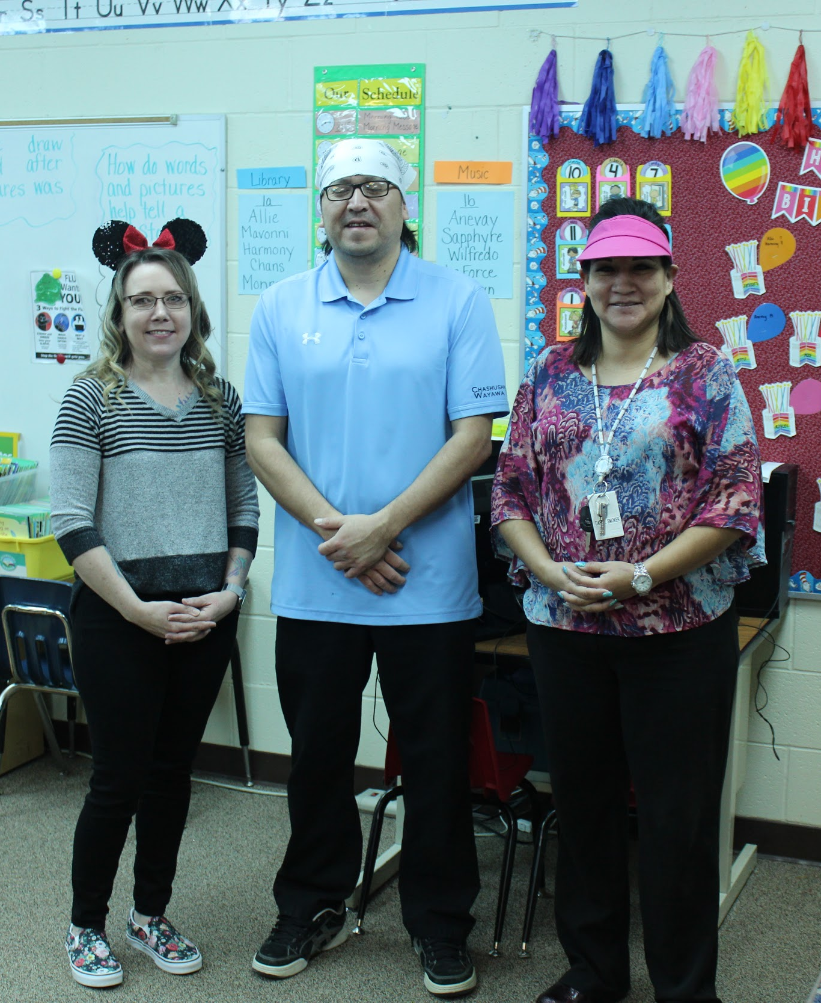
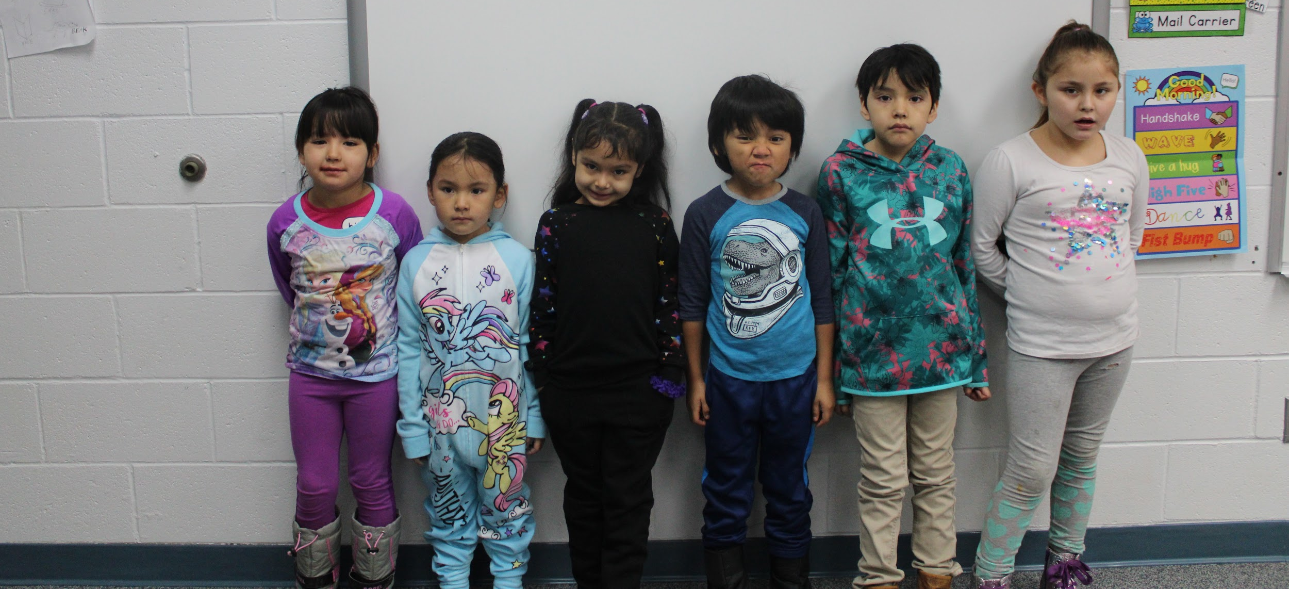
February is “I love to read month” and throughout the month the committee set-up a bunch of fun activities for the students and staff to participate in. We had a giant bingo game set up for each class, muffins for mom and donuts for dad, and other various things that you had to dress up for. We also had a reading contest and book buddies. We also thank everyone who joined in and we hope you guys have had a lot of fun this month. Happy leap year!

